Primary Source Practice: Trail of Tears

John Burnett’s Story of the Trail of Tears

John Burnett, an interpreter in the U.S. Army, recounted the horror of the Trail of Tears from the stockade experience to the end of the painful journey.

The removal of Cherokee Indians from their life long homes in the year of 1838 found me a young man in the prime of life and a Private soldier in the American Army. Being acquainted with many of the Indians and able to fluently speak their language, I was sent as interpreter into the Smoky Mountain Country in May, 1838, and witnessed the execution of the most brutal order in the History of American Warfare. I saw the helpless Cherokees arrested and dragged from their homes, and driven at the bayonet point into the stockades. And in the chill of a drizzling rain on an October morning I saw them loaded like cattle or sheep into six hundred and forty-five wagons and started toward the west.

One can never forget the sadness and solemnity of that morning. Chief John Ross led in prayer and when the bugle sounded and the wagons started rolling many of the children rose to their feet and waved their little hands good-by to their mountain homes, knowing they were leaving them forever. Many of these helpless people did not have blankets and many of them had been driven from home barefooted.

On the morning of November the 17th we encountered a terrific sleet and snow storm with freezing temperatures and from that day until we reached the end of the fateful journey on March the 26th, 1839, the sufferings of the Cherokees were awful. The trail of the exiles was a trail of death. They had to sleep in the wagons and on the ground without fire. And I have known as many as twenty-two of them to die in one night of pneumonia due to ill treatment, cold, and exposure. Among this number was the beautiful Christian wife of Chief John Ross. This noble hearted woman died a martyr to childhood, giving her only blanket for the protection of a sick child. She rode thinly clad through a blinding sleet and snow storm, developed pneumonia and died in the still hours of a bleak winter night, with her head resting on Lieutenant Greggs saddle blanket…

Color code answers - Use colored pencils to underline the answers to the following questions:

1. How does the author feel about what is going on? __________________. Underline evidence to support your claim.

2. Why was the author chosen to help remove the Indians?

3. The Indian Removal Act was signed in 1830 yet this removal took place in 1838, after a court battle that the Cherokee won, to no avail. Jackson was going to remove them regardless. At this point, do they go willingly?___ Underline evidence from the text.

4. When the author states “the trail of exiles is a trail of death,” what does he mean? Underline evidence of his belief.

5. How does the author characterize her and why does he say this about her?

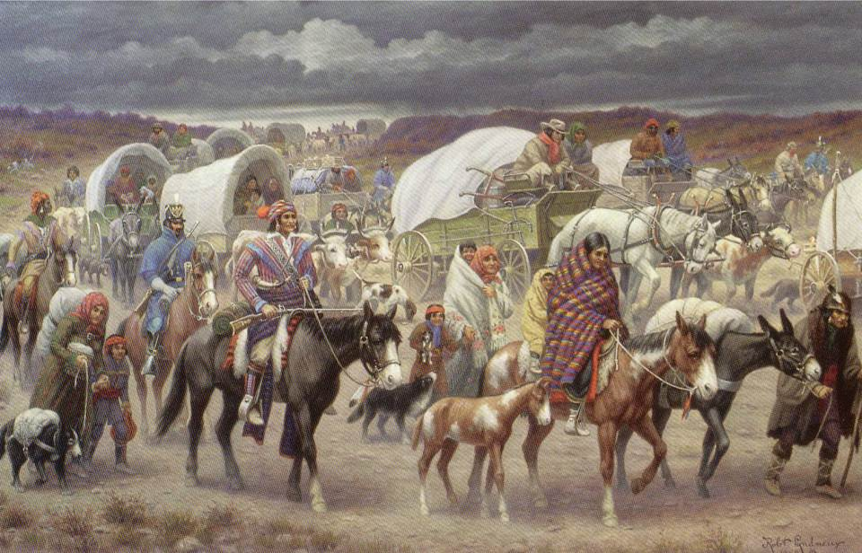

The Trail of Tears, painted by Robert Lindneux in 1942

1. List 3 observations you notice in this picture:

2. Based on what you read in the account, what is missing from this picture?

3. Why do you think it was left out?

4. This painting was created in 1942. What do you think the artist’s purpose was?

5. Which source do you think is more effective at depicting the Trail of Tears? Why?

